| RESUME | Dustin Monson |
| --- | --- |
| **12/12/2021** |  |
|  | 11943 Pepperidge Rd  Brainerd, MN 56401 Ph: (320) 293-2442 Email: mrhawghunter@hotmail.com  [Www.hawghunterzguideservice.weebly.com](http://www.hawghunterzguideservice.weebly.com)  [Www.facebook.com/hawghunterzguideservice](http://www.facebook.com/hawghunterzguideservice)  Instagram: hawghunterzguideservice |

|  | **Objectives**  To attain a Pro Staff position with Otter Outdoors.  **Education**  **Saint Cloud State University**  May 2016  Master of Science: Marriage and Family Therapy  Bachelor of Arts: Criminal Justice (minor: Community Psychology)  **experience**  Fishing Guide **|** **Hawg Hunterz Guide Service**  2016 – Present  **skills/Accomplishments/Sponsors**  **Hawg Hunterz Guide Service – Guide/Pro Staff**  May. 12, 2016  **Minnesota Grand Master Angler 2016**  **King of the Lake Winner (5 times) – Mr. Heater**  January 22, 2017-Feb. 28, 2018  **MN Master Angler (3 Species)**  January, 2017 – Present   * My social media platforms and average of 30,000 to 90,000 people on a monthly basis.   **Sponsors:** Striker Brands, Lindy Legendary Fishing Tackle, Amped Outdoors, Pradco Outdoor Brands (Smithwick Lure Co., Booyah Bait Co., Bandit Lures, Cotton Cordell), Vexan Fishing, Garmin, Tackle Industries, Monson Masonry, Flambeau Outdoors, Mister Twister |
| --- | --- |

* Feel free to check out my fishing albums from my personal Facebook profile as well. <https://www.facebook.com/dustin.monson.9>

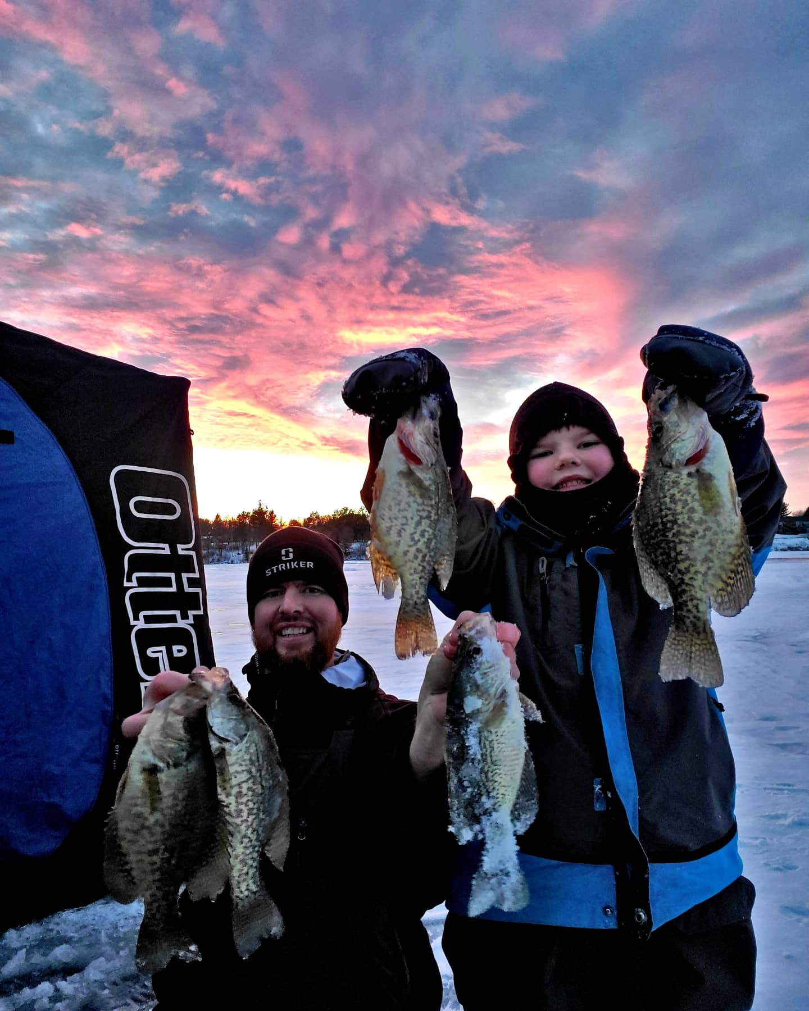

Thank you for your time, I look forward to hearing from you!

Dustin Monson,

Hawg Hunterz Guide Service

11943 Pepperidge Rd

Brainerd, MN 56401

Ph: 320-293-2442