|  |  |
| --- | --- |
| RESUME | Dustin Monson |
| 9/7/2020 |  |
|  | 11943 Pepperidge Rd  Brainerd, MN 56401 Ph: (320) 293-2442 Email: mrhawghunter@hotmail.com  Website: [www.hawghunterzguideservice.weebly.com](http://www.hawghunterzguideservice.weebly.com)  Facebook: [www.facebook.com/hawghunterzguideservice](http://www.facebook.com/hawghunterzguideservice)  Instagram: hawghunterzguideservice |

|  |  |
| --- | --- |
|  | Objectives  To attain Pro Staff/Sponsorship or Industry Partnership with Otter Outdoors.  Education  Saint Cloud State University  May 2016  Master of Science: Marriage and Family Therapy  Bachelor of Arts: Criminal Justice (minor: Community Psychology)  experience  Fishing Guide | Hawg Hunterz Guide Service  2012 – Present  skills/Accomplishments/Sponsors  **Hawg Hunterz Guide Service – Fishing Guide (Minnesota)**  May. 12, 2012-Present  **Minnesota Grand Master Angler 2016**  Jul. 3, 2016  **MN Master Angler-2 Species**  Feb. 7, 2016  **Mepps Master Angler-4 species**  Dec. 31, 2015  **MN Master Angler-2 species**  Dec. 31, 2015  **King of the Lake Winner (5 times) – Mr. Heater**  January 22, 2017-Feb. 28, 2019  **MN Master Angler (3 Species)**  January, 2017 – Present  **Sponsors:** Lindy Legendary Fishing Tackle, Smithwick Lure Co., Booyah Bait Co., Vexan Fishing, Amped Outdoors, Flambeau Outdoors, Mister Twister, Mepps, Jiffy, Garmin |

* Feel free to check out my fishing albums from my personal Facebook profile as well. Here is the link for the profile: <https://www.facebook.com/dustin.monson.9>

Misc. Photos

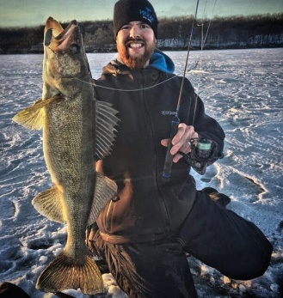 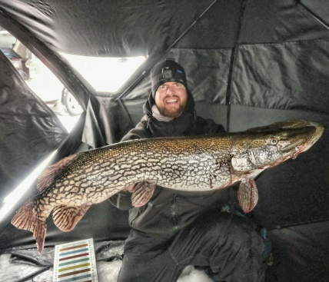

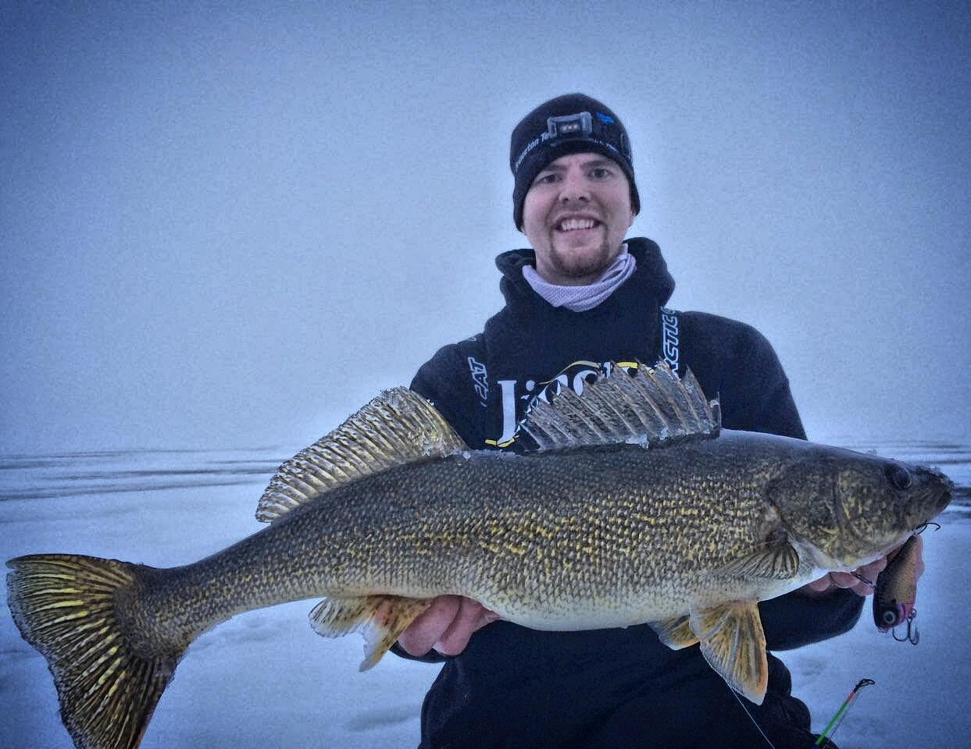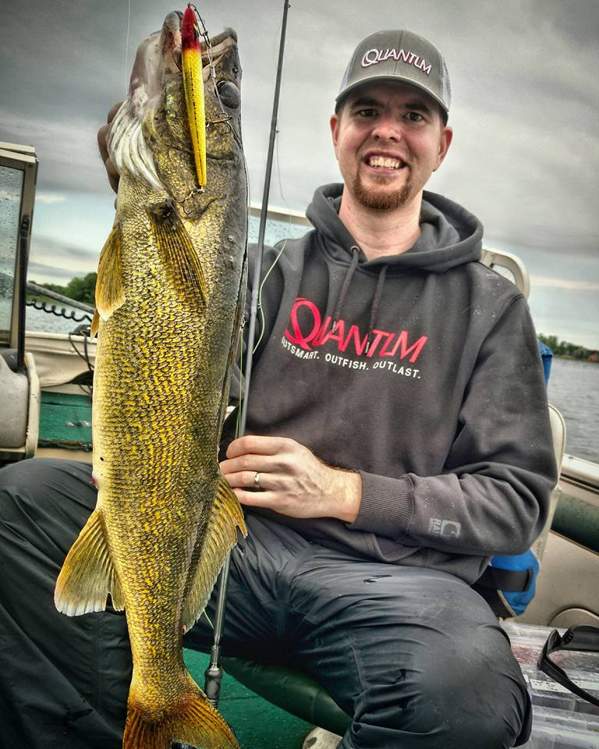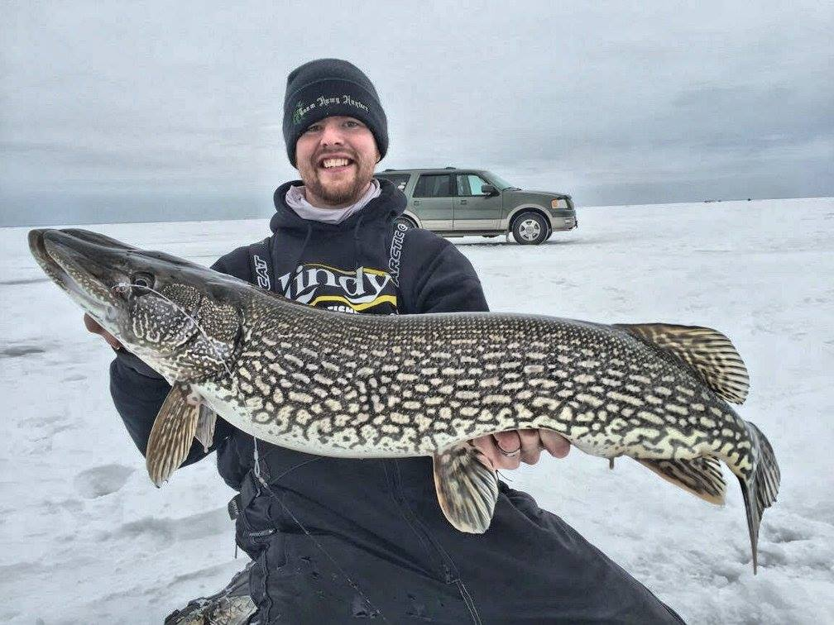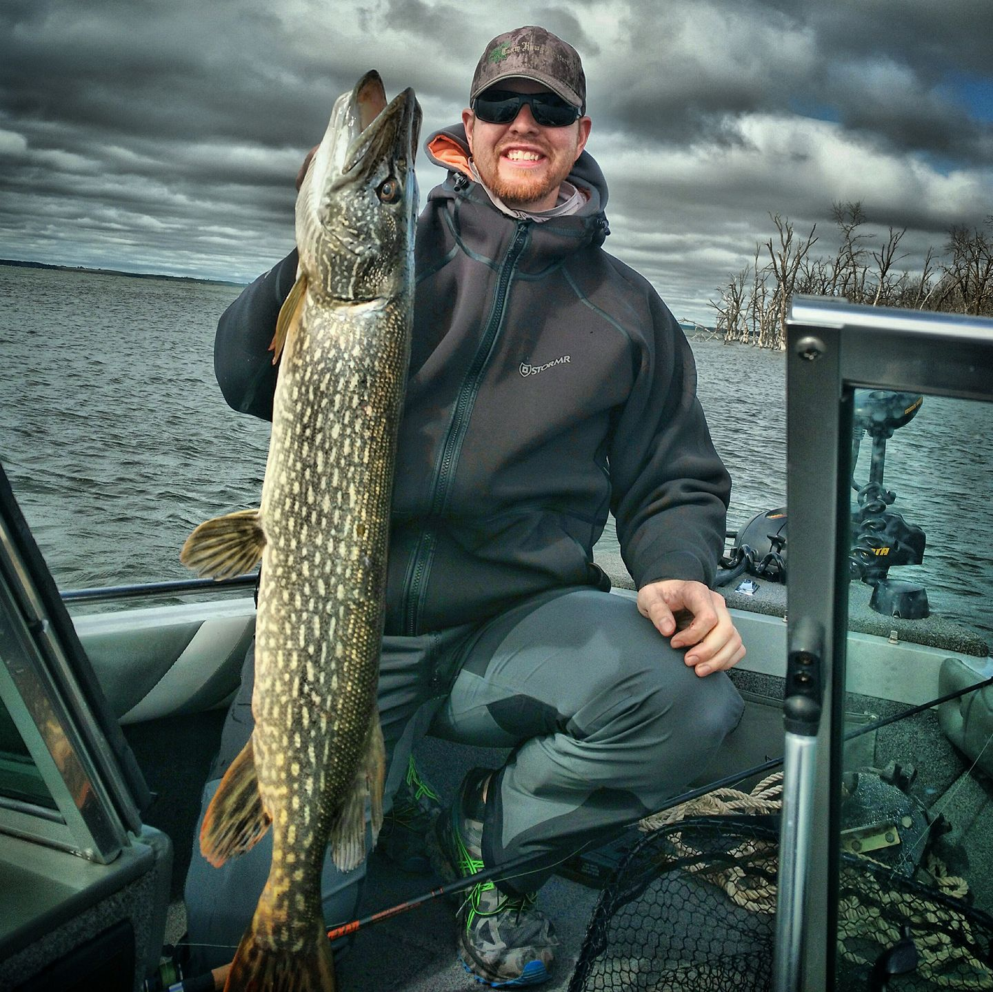

Thank you for your time, I look forward to hearing from you!

Respectfully,

Dustin Monson

Hawg Hunterz Guide Service

11943 Pepperidge Rd

Brainerd, MN 56401

Ph: 320-293-2442