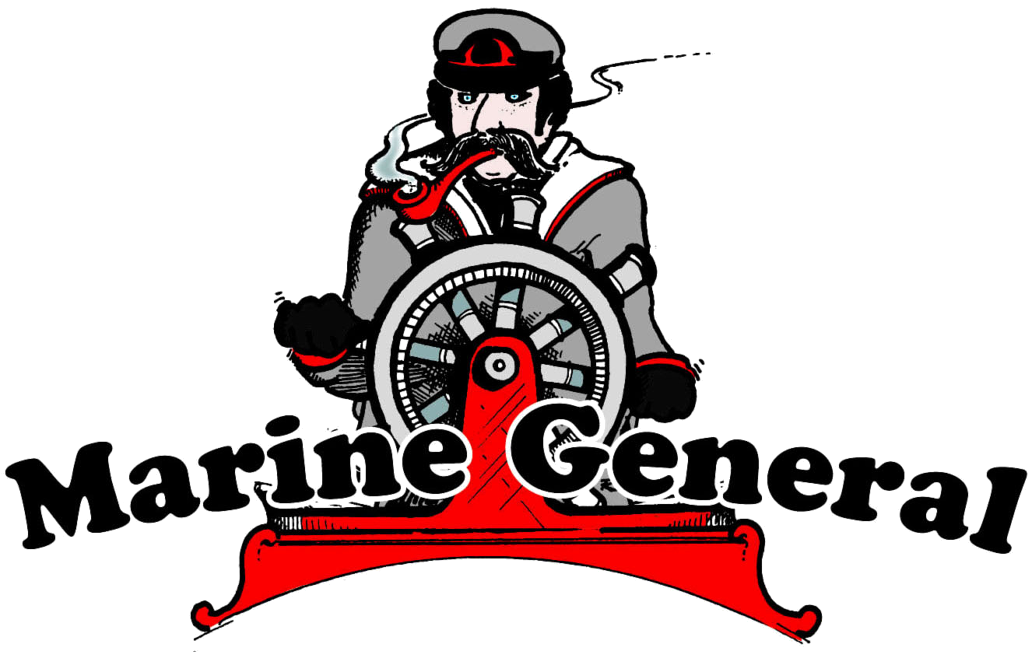 | INVOICE
Marine General  Get outdoors with us! | Date: November 15, 2019  INVOICE #682741
1501 London Rd, Duluth, MN 55812
Phone 218-724-8833 Fax 218-724-8704
info@marinegeneral.com; www.marinegeneral.com

To | Jeff Mcgregor  927 Jefferson St  Anoka, MN 55303 | SHIP  TO | same

salesperson | job | shipping method | shipping terms | delivery date | payment terms | due date
JF |  | SPEEDEE | PPD |  | CREDIT CARD

qty | item # | description |  | unit price | discount | line total
1 | 201111 | Otter xth pro lodge hub |  | 299.99 | 0.00 | 299.99
 |  |  | Total discount |  | 0.00 | 0.00
Thank you for your order. |  |  | Subtotal |  |  | 299.99
 |  |  | Sales Tax |  |  | 25.12
 |  |  | Total |  |  | 325.11
Make all checks payable to Marine General
Thank you for your business!

