Rhino Xpress 20 Trailer Assembly Instructions
200659 Tipper latch
990034 Axle
200583 Latch Bracket
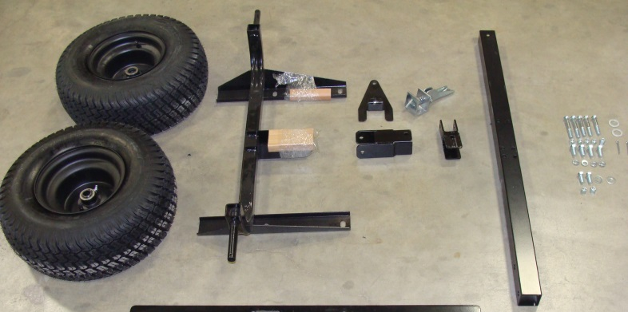
Tools Required:
990038 Hdwe bag
Ratchet
990035 Tires 18 x 8.5-8
Extension for ratchet
9/16” socket
200661 Tongue
9/16” wrench
200666 Tongue pivot
5/8” socket
Pliers
990037 Pin coupler
Hammer
7/16 x 1 Bolt and lock washers
3/8 Bolts and nylock nuts

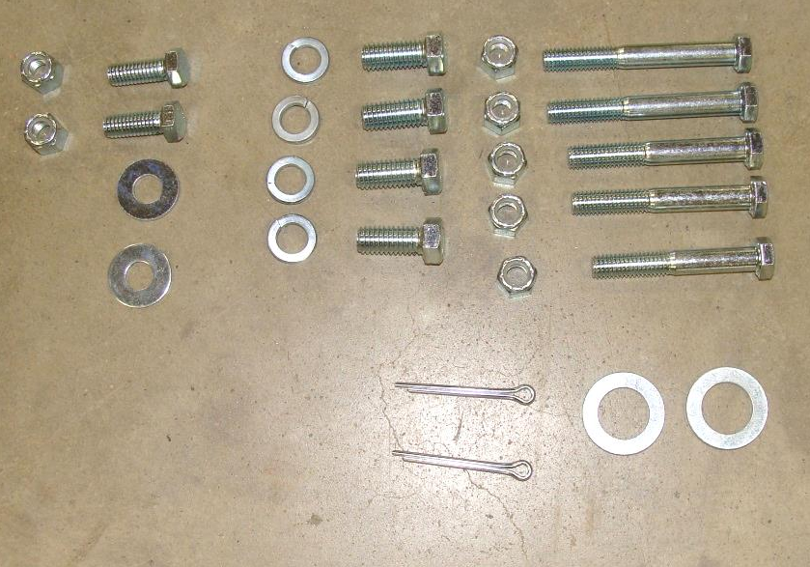
3/8 x 3”

3/8 x 2 ¾”
3/8 x 2 ½”
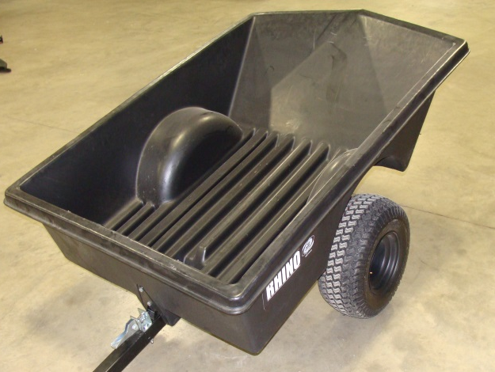
3/8 x 1 Bolt, washers, nylock nuts
3/4“ machine washers
Cotter pins
200791 Plastic Trailer Body

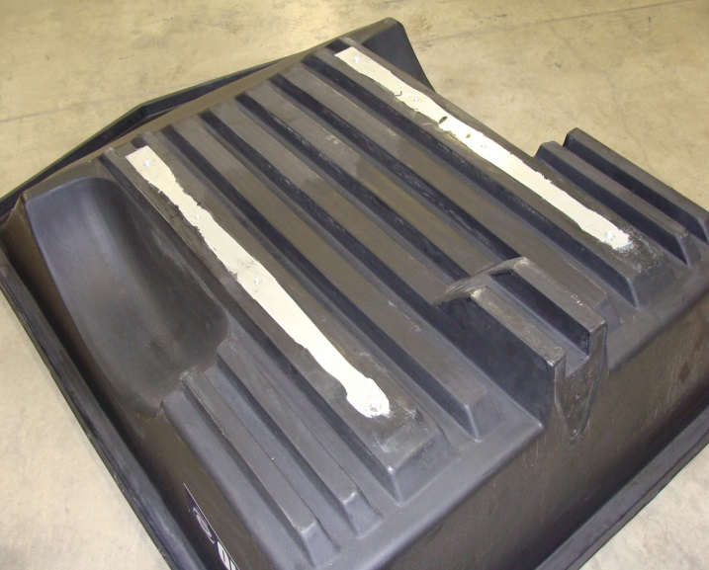
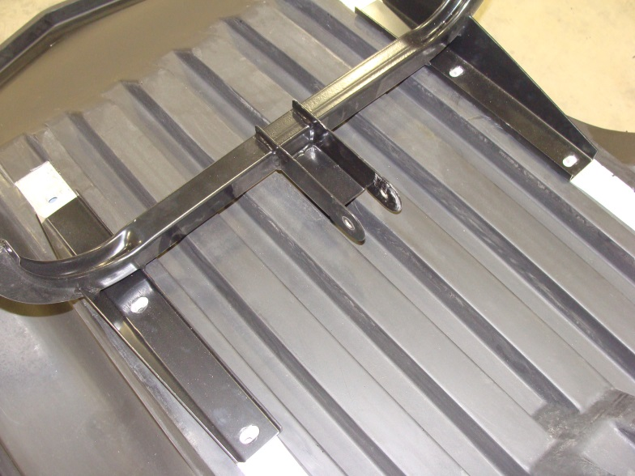
- Turn trailer body upside down and align the axle with the 7/16” threaded holes in the aluminum power rails which are molded into the trailer body. Tighten securely using the 7/16 x 1” bolts and lock washers.
Power rails.

Position axle over the smaller threaded holes in the power rail.

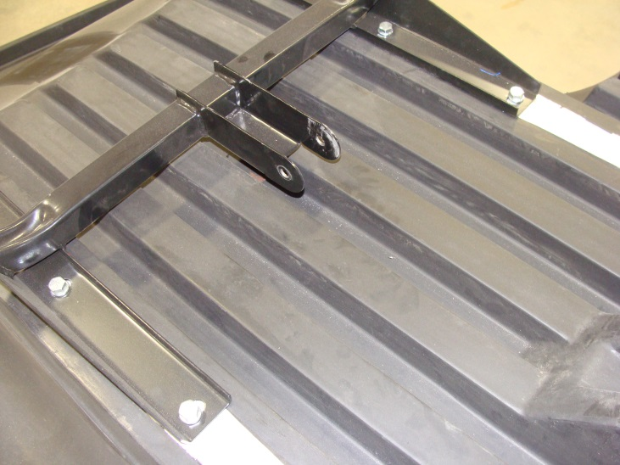

Secure here with the 7/16x1” bolts and lock washers.

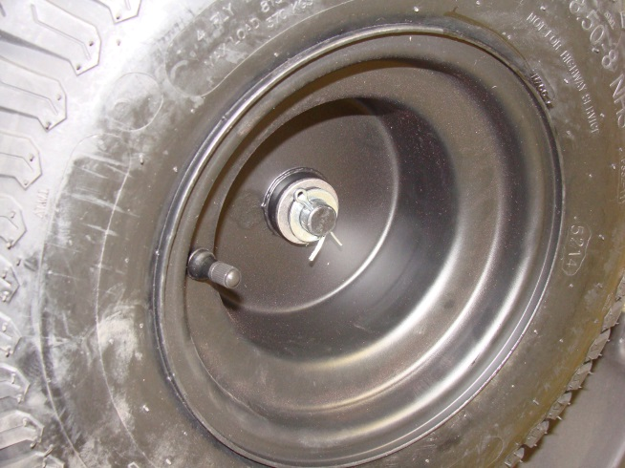
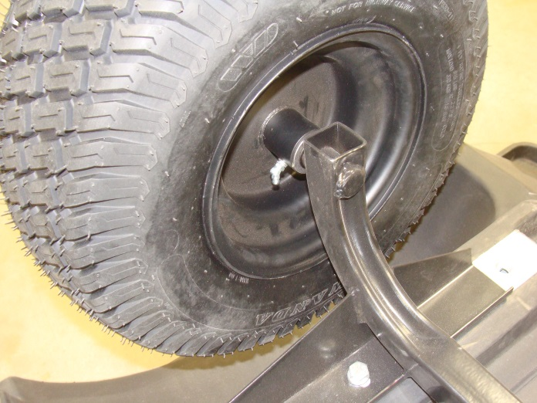
- Slide wheels onto the axle stub as shown. Grease zerk should be on the inside. Next slide the ¾” machine washer onto the axle stub and place the cotter pin thru the hole in the axle stub. Be sure to bend cotter pin over to hold the wheel onto the axle. Note: Grease before using.
¾” machine washer.

Grease zerk.
Cotter pin

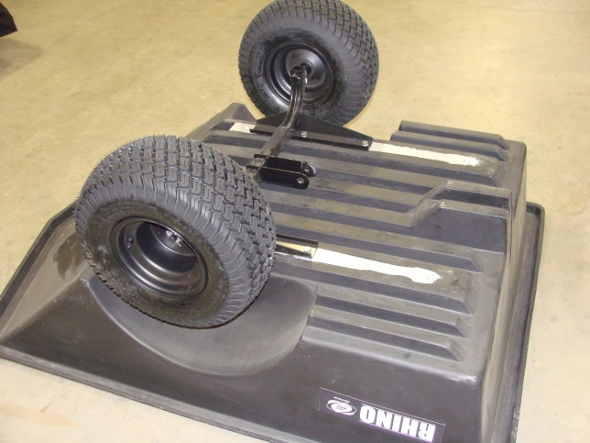

Both wheels installed.

- Install tongue pivot onto the axle frame as shown. The hole is off center and should be mounted as shown. Secure with the 3/8 x 3” bolt and 3/8” nylock nut. Tighten the nut enough to hold pivot securely yet allow it to freely move with no excess play.
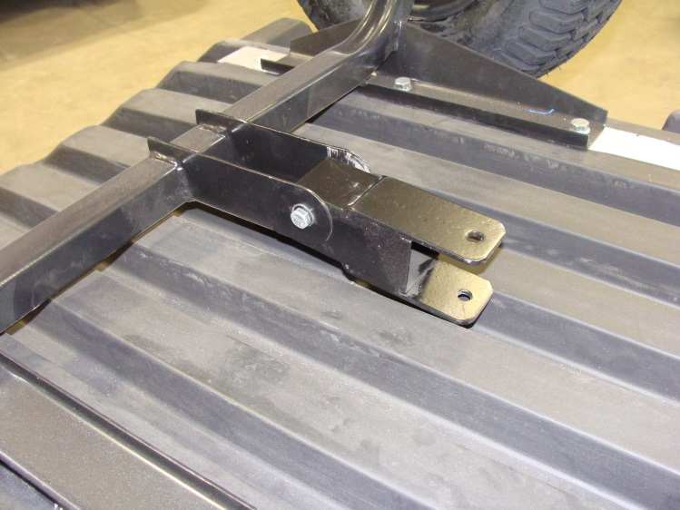
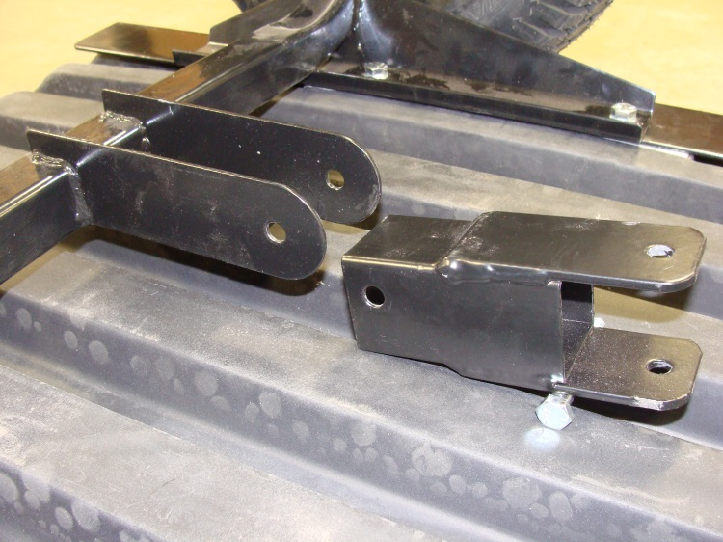

3/8 x 3” bolt and nylock nut
Tongue pivot.

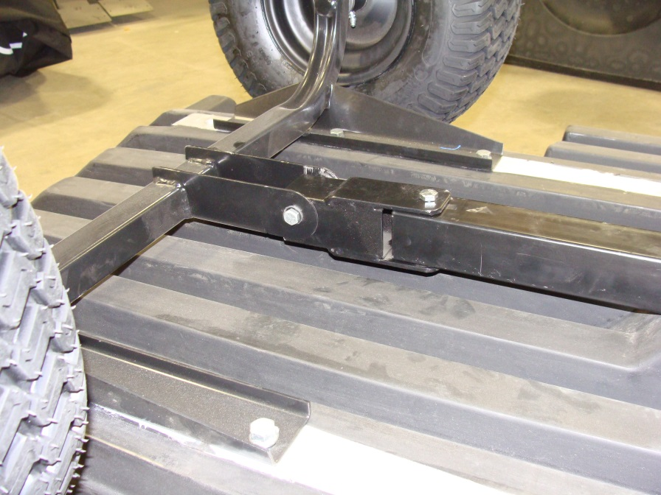
- Attach tongue to the pivot using the 3/8 x 3” bolt and nylock nut. Tighten the nut enough to hold tongue securely yet allow it to freely move with no excess play.

Attach tongue here with 3/8 x 3” bolt and nylock nut.
- Attach latch bracket to the front of trailer body using the 3/8 x 1” bolts, washers and nylock nuts.
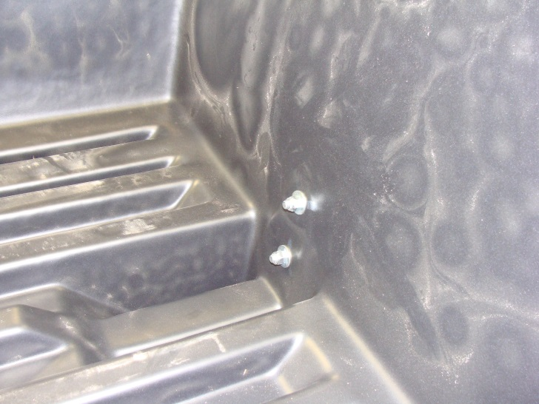
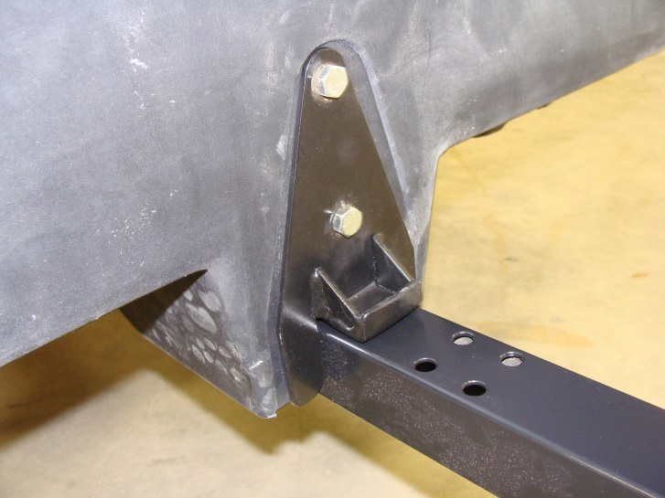
3/8 x 1” bolt attaches here.

3/8 nylock nut and washer goes here on the inside of trailer body.

- Attach tipper latch to the trailer tongue using the middle set of holes in the tongue. Secure with 3/8 x 2 3/4” bolts and 3/8 nylock nuts. Flipping the latch lever up will make it easier to fit a socket on the bolt. Move the tipper latch in the slots so there is just enough room for the catch to clear the bracket. Tighten securely once the proper mounting position is achieved.
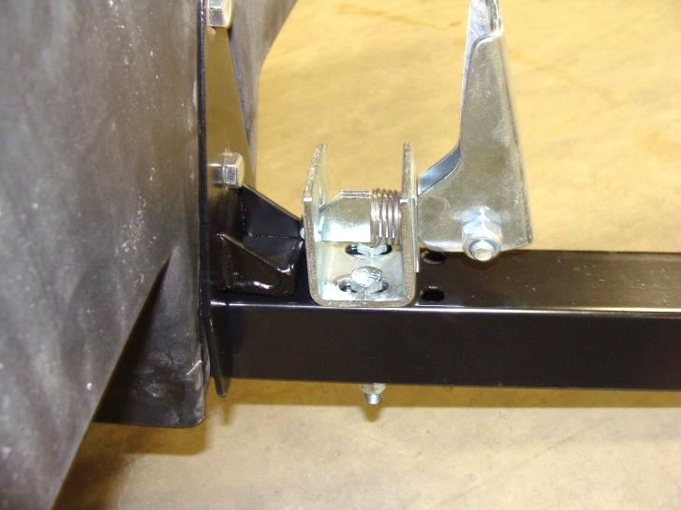
Lever flipped up.

3/8 x 2 3/4” bolt and nylock nut
Gap between tipper latch and bracket should be just enough to allow it to work.

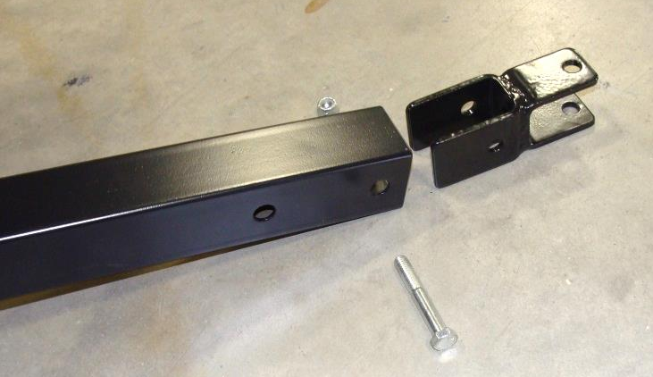
- Insert pin coupler into the tongue and fasten securely with the 3/8 x 2 ½” bolt and nylock nut. It may be necessary to tap the pin coupler into place with a hammer.

